**SRI DASARI NARAYANA RAO**

**GOVERNMENT DEGREE COLLEGE FOR WOMEN**

**DEPARTMENT OF TELUGU**

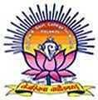

**1982**

**PALAKOL**

**WEST GODAVARI DISTRICT – 534 260**

**ANDHRA PRADESH**

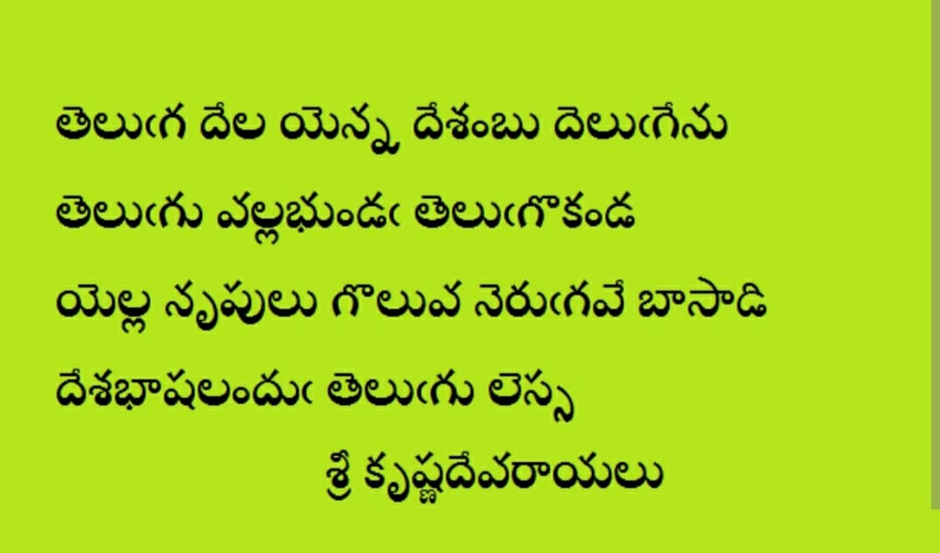

**ITALIAN OF THE EAST**

NICCOLO DE CONTI - 1420 ITALIAN TRAVELER

తేనె కన్నా తీయనిది తెలుగు భాష

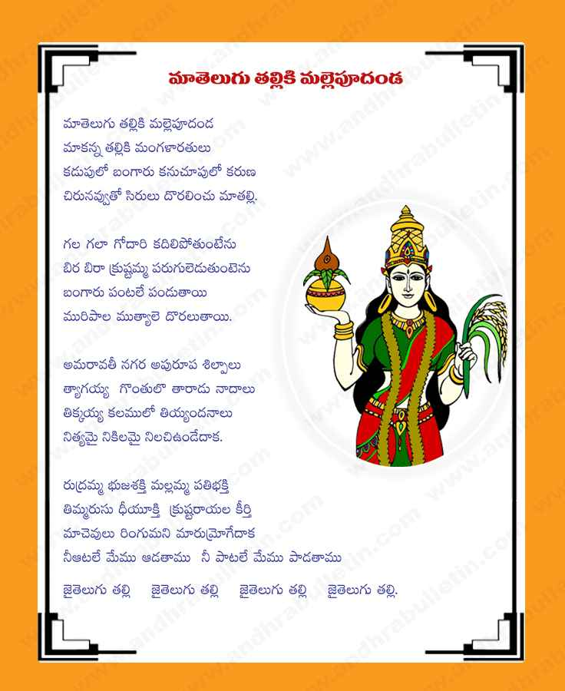

SRI DNR GOVT. DEGREE COLLEGE FOR WOMEN

DEPARTMENT PROFILE

DEPARTMENT OF TELUGU

Sri Dasari Narayana Rao Govt. Degree College For Women – Palakol is established in the year 1982. This Institution is at first affiliated to Andhra University, Visakhapatnam. Later after the establishment of the Adikavi Nannaya University, this college has been under affiliation from 2012 this prestigious institution is affiliated to Adikavi Nannaya University, Rajahmahendravaram.

The department of telugu has its inception in the year 1982. The department is offering Telugu as second language for all UG courses. The department also offering certificate course in Telugu Journalism.

COURSES OFFERED

|  |  |  |
| --- | --- | --- |
| S.NO | NAME OF THE COURSE | GROUP |
| 1 | B.A | HISTORY;ECONOMICS;POLITICS |
| 2 | B.COM | GENERAL |
| 3 | B.COM | COMPUTERS |
| 4 | B.SC | MATHEMATICS;PHYSICS;CHEMISTRY  MATHEMATICS;PHYSICS; COMPUTER SCIENCE  CHEMISTRY;BOTANY;ZOOLOGY |

STAFF PARTICULARS

1982 – 2022

|  |  |  |
| --- | --- | --- |
| S.NO | NAME OF THE FACULTY | YEAR OF WORK |
| 1 | SMT. B. KAMALA KUMARI | 1982 -1990 |
| 2 | SMT. N. APPALA SITA RAVANNA | 1990 -1994 |
| 3 | SRI. SK. RAZAK | 1994 -1997 |
| 4 | SRI. V.C. RAMASUBBA REDDY | 1999 – 2001 |
| 5 | SRI. M. RAVI KUMAR | 2001 – 2006 |
| 6 | SRI. N.V.S. NAGABHUSHANA CHARYULU | 2006 – 2010 |
| 7 | SMT. V. ALICE RAJA KUMARI | 2015 - 2017 |
| 8 | SK. JAREENA BEGUM | 2018 – 2021 |
| 9 | SRI. JOHN NOBLE JAWAHAR RAJ | 2021 - |